MODULE 4 – INTRODUCTION TO DBMS

LAB EXERCISES

6. DROP Command
Lab 1.
Drop the teachers table from the school_db database.
Ans.
1. DROP TABLE teachers
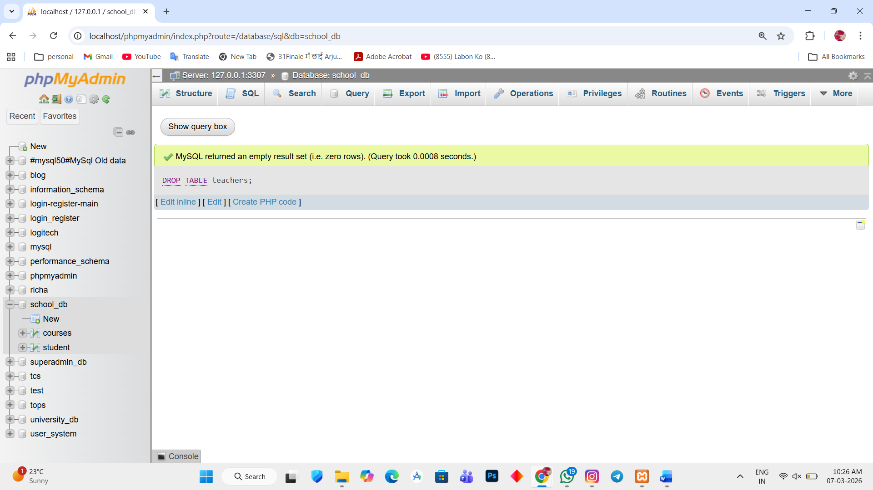

Lab 2.
Drop the students table from the school_db database and verify that the table has been removed.
Ans.
1. DROP TABLE student
